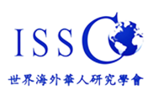
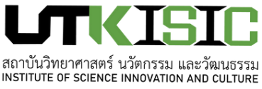

2023 CALL FOR PAPERS
International Conference of ISSCO Chinese Overseas:
Integration, Identities, and Transnational Connectivity
DECEMBER 9-10

Registration Form
Participant Only Participant + Presenter

Attach Photo Here

PERSONAL INFORMATION

Full Name : Address :

Date of Birth : / /

Gender :

Nationality :

Email :

Mobile Phone No. WeChat :

Registration Fee: US$80.00
Affiliation :

Position :

Address :

Country :

Post Code :

Are you interested to join the Field Trip for an additional Fee?
YES NO

Payable during conference or deposit to bank, for details, please contact person-in-charge below.

For Presenters, please write the Title of your Article below:

Contact Persons:
Mrs. Ada Marie (English) Tel. (+66) 0949488980 (mobile & line) Email: ada.marie@mail.rmutk.ac.th

Miss Samini Sukchan (Thai) Tel. (+66) 0851829586 (mobile & line) Email: samini.s@mail.rmutk.ac.th
www.isic.rmutk.ac.th
Miss Mo Liu (Chinese) Tel. (+66) 0615248005 (mobile) Email: liu.m@mail.rmutk.ac.th

Registrant Signature

Officer Signature
THANK YOU FOR REGISTERING
See you at the Conference!

